Ulster for Business

<http://ulstercountyny.gov/ulsterforbusiness>

HOME PAGE

**Make Ulster County Your Home for Business**

**Relocating your business to Ulster County? Ready to expand operations – or start a new business? The Ulster County Office of Economic Development provides the expertise and resources you need.**

Hundreds of businesses have benefitted from our hands-on approach. The Ulster County Office of Economic Development provides assistance with site selection, securing funding, lowering your cost of business, and with making important connections. Our staff will help you overcome the challenges facing your business and ensure your success in Ulster County.

VIDEO: Techpreneurs: Do Business Differently in Ulster County

Recent Posts -- TOM DON’T CHANGE THIS, LET’S DISCUSS

**[Ulster County Executive Updates Progress Of Hudson Valley Rail Trail Expansion In Towns Of Lloyd, New Paltz](http://ulstercountyny.gov/news/executive/ulster-county-executive-updates-progress-hudson-valley-rail-trail-expansion-towns)**

[**For the Love of Film: The Woodstock Film Festival**](http://ulstercountyny.gov/ulsterforbusiness/blog/love-film-woodstock-film-festival)

From its humble origins, the Woodstock Film Festival has grown into a cultural tour de force, attracting celebrities and film lovers from across the world. And once they experience Ulster County, many of them come back.

[**Going Green: Ulster Is the Most Environmentally Friendly County in New York State**](http://ulstercountyny.gov/ulsterforbusiness/blog/going-green)

Fiscal responsibility and environmental sustainability are not mutually exclusive concepts to Ulster County Executive Mike Hein.

[**Farm to Fabulous: Putting the Value in Value-Added**](http://ulstercountyny.gov/ulsterforbusiness/blog/farm-to-fabulous)

Ulster County has earned its reputation as the epicenter of the farm-to-table movement.

Upcoming Events

Full list links to: <http://ulstercountyny.gov/ulsterforbusiness/events>

**ULSTER COUNTY SNAPSHOT**



**8.4%**

Projected population growth of 25-40 year olds from 2013-2020



**179,417**

Total Population

(U.S. Census Bureau Quick Facts)

https://www.census.gov/quickfacts/fact/table/ulstercountynewyork/SBO060212



**90.1%**

High school diploma or more

**31%**

Bachelor's Degree or more

(U.S. Census Bureau Quick Facts)

<https://www.census.gov/quickfacts/fact/table/ulstercountynewyork/SBO060212>



**3.7%**

Unemployment

(as of May 2018)

U.S. Bureau of Labor Statistics

<https://fred.stlouisfed.org/series/NYULST0URN>



**$215,000**

Median home value

(2017, NYS Dept. of Taxation and Finance)

<https://www.tax.ny.gov/research/property/assess/sales/resmedian.htm>



**$60,393**

Median household income

(2012-2016)

U.S. Census Bureau Quick Facts

<https://www.census.gov/quickfacts/fact/table/ulstercountynewyork/SBO060212>

<http://ulstercountyny.gov/ulsterforbusiness/about>

**About Us**

The Ulster County Office of Economic Development opens doors and helps businesses excel. We are available to help your businesses grow and thrive and provide critical assistance to new businesses seeking to locate here. The Ulster County Office of Economic Development provides valuable business counseling and can connect you with the best sites, the right funding partners and strategic programs for business development.



Suzanne Holt, Esq.

leads Ulster County Executive Mike Hein’s Office of Economic Development. She and her team are responsible for fostering community and economic growth by supporting local businesses with their efforts to grow and thrive, as well as helping new businesses locate within the County and succeed.

Suzanne serves on the County’s Workforce Investment Board and the Tourism Advisory Board and she represents Ulster County Executive Hein on the Governor’s Mid-Hudson Regional Economic Development Council. Because of her tireless efforts, *Hudson Valley Magazine*named Suzanne its 2015 Women in Business Awardee and the YWCA of Ulster County honored her as its 2015 Woman in Government. Prior to devoting herself to Ulster County’s success, Suzanne helped older Americans and people with disabilities to access needed health coverage. Suzanne has a law degree from Cardozo Law School and she graduated from the University of Oklahoma’s Economic Development Institute.

She and her family choose to live in New Paltz because of the area’s natural beauty and easy access to trail running, biking and swimming.



Evelyn Heinbach

is a Senior Economic Developer in County Executive Mike Hein’s Office of Economic Development and the office liaison to the Ulster County Industrial Development Agency (U.C.I.D.A.).

Evelyn focuses on job creation by working with existing Ulster County businesses as well as attracting new businesses to Ulster County. She offers expert business consulting services, supports businesses with site selection, connects businesses with funders, and identifies programs and partners for growth. Evelyn is an experienced business executive with 20+ years of experience in the consulting, financial services and manufacturing industries.

She and her family are avid ultra-runners who enjoy covering Ulster County’s trails on foot live. They live in New Paltz and, when they are not running, you can find them enjoying farm-to-table foods and local restaurants.

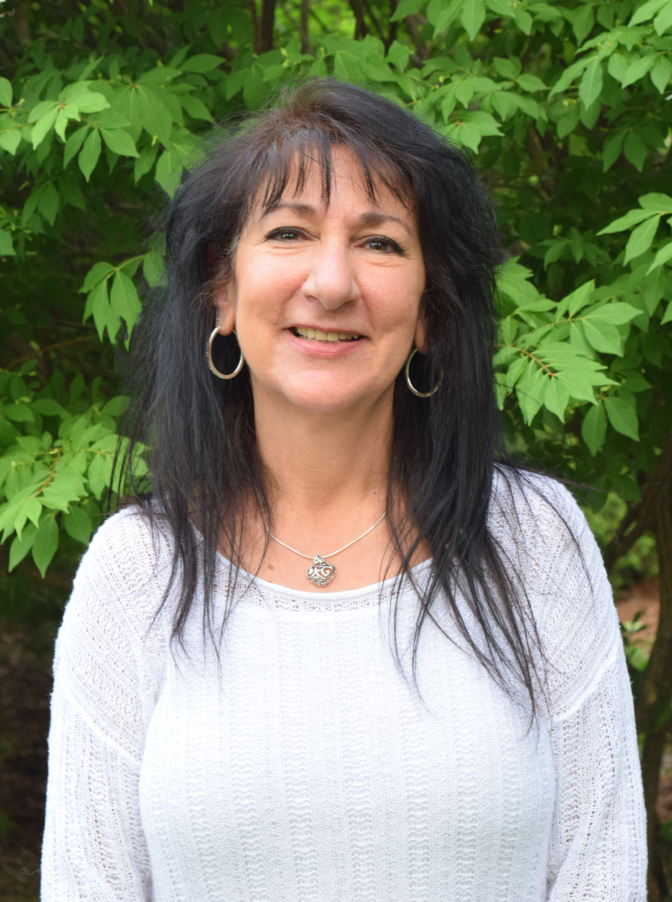

Bernadette Andreassen

is an Economic Developer in County Executive Mike Hein’s Office of Economic Development and the liaison to the Ulster County Economic Development Alliance (U.C.E.D.A.). Bernadette’s expertise stems from more than 30 years of working in the field of real estate, including the sale, purchase and funding of commercial, residential and agricultural properties throughout Ulster County.

Bernadette is passionate about growing Ulster County’s economy so that our young people can remain or return after college and find meaningful employment. She is keenly aware of the need to work with each town, village and the City of Kingston to meet regional economic development needs while preserving our spectacular environment.

Bernadette enjoys the beauty of Ulster County when golfing on our pristine courses and while riding our rural roads on the back of a motorcycle.

<http://ulstercountyny.gov/ulsterforbusiness/food-beverage> - NEEDS NEW URL & OVERVIEW CONTENT AS LANDING PAGE FOR THE ENTIRE GROWTH INDUSTRIES SECTION

**NEED 3 IMAGES TO REPRESENT ALL 3 OF THE INDUSTRIES AT TOP OF PAGE**

**Text across image(s):**

**Ulster County’s growth industries—craft foods & beverages, technology & manufacturing, and filmmaking—are vibrant and strong.**

**Ulster County’s Growth Industries (TITLE)**

Ulster County offers businesses cost-effective locations and a distinctive high quality of life for its 180,000 residents. With 2018 property taxes at their lowest rate in nearly a decade—and an impressive $61 million dollar countywide infrastructure overhaul underway—our economy is strong and inviting. Local towns and the City of Kingston have benefited from $32 million dollars in tax relief designed to help balance budgets, protect taxpayers and provide essential services. Our quality of life is excellent as well: Ulster County received the 2017 New York State Department of Environmental Excellence Award for environmental stewardship, establishing it as the first and only “Net Carbon Neutral” county in NYS.

Within this climate of exciting initiatives, Ulster County is one of the best places you’ll find to locate and grow a successful business, especially in the following industries:

**• Craft Food & Beverage << INSERT LINK TO** <http://ulstercountyny.gov/ulsterforbusiness/food-beverage> >>

**Ulster County purveyors have easy access to global markets with low costs of doing business and an emphasis on environmental integrity.**

**• Technology & Manufacturing << INSERT LINK TO** <http://ulstercountyny.gov/ulsterforbusiness/technology> >>

**Ulster County small tech, digital media, and large-scale manufacturers benefit from low overhead and an outstanding quality of life.**

**• Filmmaking << INSERT LINK TO** <http://ulstercountyny.gov/ulsterforbusiness/filmmaking> >>

**With tax credits of up to 45%, incredible local talent, and diverse shooting locations, Ulster County is the place to be for film and T.V.**

<http://ulstercountyny.gov/ulsterforbusiness/food-beverage>

Craft Food & Beverage page

**Craft Food & Beverage**

**Ulster County purveyors have easy access to global markets with low costs of doing business and an emphasis on environmental integrity.**



**60 MILLION PEOPLE**

Ulster County offers easy, affordable access to one of the world’s largest consumer markets. Within a 100-mile radius, there are more than 60 million people.



**GROWTH**

**from 2009-2014**

Ulster County’s food processing and manufacturing industry provided more than 1,300 jobs in 2014.



**GROWTH**

**projected by 2019**

The market for local food in the United States is projected to grow 66% to $20 billion by 2019.

Ulster County is known historically as New York City’s breadbasket, and our diverse businesses have easy access to statewide, national and global markets without the high real estate and labor costs. Whether you are looking for farmland or factory space, Ulster County has a wide variety of affordable options. More than 500 Ulster County farms supply high-quality, local produce to more than [50 food and beverage manufacturers](http://ulstercountyny.gov/news/business-services-economic-development-executive-press-releases/ulster-county-executive-mike-2) who, in turn, enjoy the support of a community that values local food.

Food and beverage makers benefit from services provided by the Ulster County Office of Economic Development, such as:

• Site assistance

• Low-interest loans

• Hands-on business counseling

• Networking and introductions

• Creative funding strategies

VIDEO: Taste of Craft Beverages – Ulster County

**Craft Beverages in Ulster County**

**Profiles**

[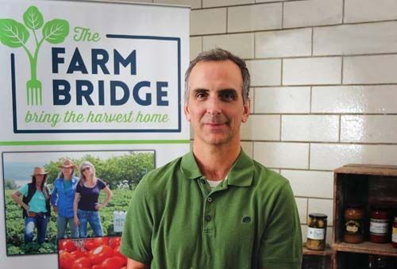](http://thefarmbridge.com/)

[**The Farm Bridge**](http://thefarmbridge.com/)

In 2006, locavore entrepreneur Jim Hyland of New Paltz wanted to freeze his own surplus produce from his Community Supported Agriculture (CSA) share so he and his family could enjoy local food during the winter. He was soon inspired to build a business to support local farms and, by 2018, The Farm Bridge has become one of the Hudson Valley’s preeminent co-packers and distributors of fresh food. The Farm Bridge collects produce from local farmers and sells it to a large network of retailers, institutions and restaurants, earning praise from the director of New York City’s Greenmarket program, who called the business “the most significant agricultural development in our region in the past 15 years.” Jim and his staff of approximately 40 people also provide advice, equipment and labor for shelf-stable, value-added products like pickles, roasted vegetables and sauces. As The Farm Bridge concept gained traction and the operation outgrew its initial 17,000 square foot facility, staff at the Ulster County Office of Economic Development provided necessary supports such as grant assistance and low-interest loans, making sure the growing operation has the capital it needs to succeed.

Today, The Farm Bridge operates from a 30,000 square foot kitchen at Tech City with dedicated processing lines for sauces, pickles, I.Q.F., roasting and handmade products. It has three loading docks and 8,000 square feet of storage space for refrigerated, frozen and dry goods—everything it needs to deliver high-quality local food to its growing customer base.

[](https://www.tastefruition.com/)

**[Fruition Chocolate Works and Confectionery](https://www.tastefruition.com/)**

Fruition Chocolate has exploded in popularity. The small batch bean-to-bar chocolatier based in Shokan makes artisanal culinary delights, often partnering with local farms for fruit fillings and flavors. Fruition chocolates are handcrafted from ethically sourced fine flavor cocoa beans from Peru, Ecuador, The Dominican Republic, Costa Rica, Nicaragua and Bolivia.

When Bryan Graham founded Fruition in 2011, there were only a small handful of craft chocolate companies in America: Today, there are several hundred and Fruition, whose staff includes alumni from The Culinary Institute in Hyde Park, has earned multiple top honors at the International Chocolate Awards in London—their Marañón Canyon Dark Milk Chocolate bar won “2016 Best In Competition”—among other prestigious chocolate competitions.

Graham started Fruition with a very small team but, in 2018, with six full time staff and production of more than a ton of high quality chocolate each month, Ulster County officials are assisting the growing business by helping its owners find a suitable production location in which to expand.

<http://ulstercountyny.gov/ulsterforbusiness/technology>

**Technology & Manufacturing**

**Ulster County small tech, digital media, and large-scale manufacturers benefit from low overhead and an outstanding quality of life.**



**PER SQUARE FOOT:**

**MANHATTAN**

Average price per square foot of office space in Manhattan: $72.

Average price per square foot of Class A buildings in Manhattan: $79.

<https://www.squarefoot.com/ny/new-york/office-space>



**PER SQUARE FOOT:**

**ULSTER COUNTY**

Average price per square foot for leased office space in Ulster County: $6-10.

<http://www.loopnet.com/new-york/ulster-county-commercial-real-estate/>



**90 MINUTES**

**FROM NYC**

Ulster County is only 90 minutes from New York City. With direct buses, nearby Amtrak and MetroNorth train service, and the N.Y.S. Thruway, getting here couldn’t be easier.

While Ulster County has long been attractive for manufacturers, it is now a hub for small tech and digital media businesses too. With millions of square feet of both office and industrial space available at a fraction of New York City prices, Ulster County’s designers, makers and entrepreneurs have a significant competitive advantage: lower overhead. Many in the tech industry choose Ulster County for its natural beauty and quality of life. Only 90 minutes from New York City, Ulster County residents and businesses still benefit from easy access to one of the largest markets—for customers AND for talent—on the planet.

VIDEO: ADD NEW NICHE MANUFACTURING VIDEO ABOVE DENNIS CROWLEY’S VIDEO

VIDEO: Living in Ulster County – Dennis Crowley Testimonial

**Profiles**

PHOTO OF FALA DOESN’T APPEAR ON MY SCREEN – SHOULD BE ONE OF FRANK WITH YOUNG PEOPLE

[**Fala Technologies**](http://www.falatech.com/page.asp?pageid=2)

CONTENT FOR THIS WILL BE FURTHER UPDATED

Fala Technologies designs and builds innovative components for a variety of high-tech applications, from the electric car to next-generation helicopters. Global-scale manufacturers look to Fala for its expertise and demonstrated capability. Recently, owner Frank Falatyn has been working with Kingston High School to design programming classes that will train the local workforce for next-generation careers in advanced manufacturing.

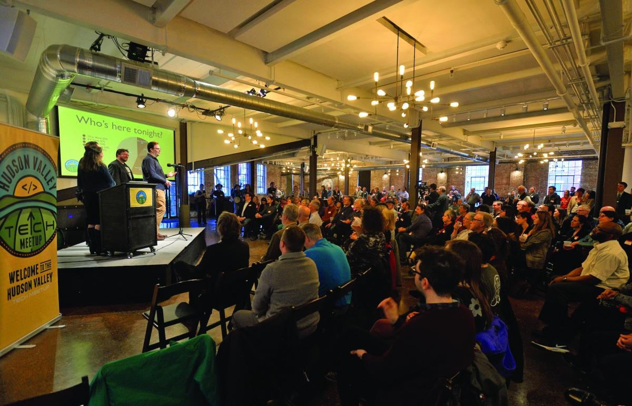

[**Hudson Valley Tech Meetup**](https://www.meetup.com/hvtech/)

CONTENT FOR THIS WILL BE FURTHER UPDATED…

Digital entrepreneurs Kale Kaposhilin and Dan Stone of Kingston's Evolving Media Network co-founded the Hudson Valley Tech Meetup in 2014. It has since gained thousands of members, and each Tech Meetup convenes app developers, programmers, graphic designers and other members of the tech community for networking and presentations by industry leaders. Meetups have featured many of the area’s tech luminaries, such as Dennis Crowley, co-founder of Foursquare, and Tim Brown, Head of Typography for Adobe Typekit and Adobe Type. A spin-off group, StartupHV, hosts a monthly event to put startups in the hot seat for crowd-sourced refinement of their business models.

<http://ulstercountyny.gov/ulsterforbusiness/filmmaking>

**Filmmaking**

**With tax credits of up to 45%, incredible local talent, and diverse shooting locations, Ulster County is the place to be for film and T.V.**



**TAX CREDIT**

Ulster County boasts a tax credit of up to 45%, making the location internationally competitive for production and post-production.



**DIVERSE SHOOTING LOCATIONS**

Ulster County’s mix of urban and rural spaces provides filmmakers with a variety of shooting locations.



**GROWTH**

Ulster County’s film industry is expected to grow as much as tenfold in the coming years as a result of the tax credit.

ADD “ULSTER IS CAMERA READY” VIDEO & TEXT TO THIS PAGE

Ulster County is no stranger to the silver screen, and with a nationally competitive tax credit of up to 45% and no M.T.A. payroll tax, it has taken center stage. From Kingston’s urban cityscape to the Catskills Mountains and Mohonk Mountain House’s elegant, natural beauty, you’ll find a wealth of diverse filming locations to suit almost any project. With inexpensive lodging and a lower cost of goods and services, filming in Ulster County just makes sense.

**Profiles**

[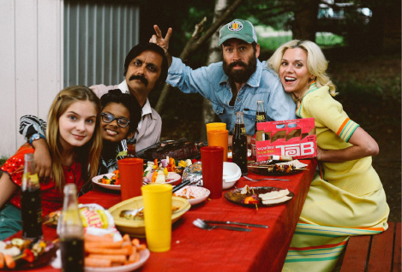](https://www.hudsonvalleyfilmcommission.org/)

[**Hudson Valley Film Commission**](https://www.hudsonvalleyfilmcommission.org/)

Since 2000, the Hudson Valley Film Commission (H.V.F.C.) has worked consistently to develop sustainable economic initiatives in the Hudson Valley and Catskill region. Founder and director, Laurent Rejto, works directly with filmmakers to make it as easy as possible to choose Ulster County for their next project. The H.V.F.C. is a tremendous asset to any production and supports productions by helping to secure crew, cast, locations, vendors, post-production facilities and more. They have worked with more than 500 productions and tracked well over $100-million in direct local spending

INSERT Photo

**[Woodstock Film Festival](http://woodstockfilmfestival.org)**

Hailed as “a true American Maverick among fests,” the Woodstock Film Festival (W.F.F.) was founded in 1999 and is named among the world’s top 50 film festivals. Co-founded by Meira Blaustein and Laurent Rejto, the W.F.F. premieres exceptional films and hosts the most talented emerging and established movie industry professionals. The W.F.F. presents an exceptional lineup of fiercely independent films, as well as A-list concerts, panels and parties at their annual festival, and creates stimulating, innovative programming throughout the year. The festival attracts visitors from all over the world to film screenings and special events in Woodstock, Rhinebeck, Kingston, Saugerties and Rosendale. The W.F.F. is a non-profit, 501 c3 located in the cultural heart of Ulster County.

[](http://bcdfpictures.com/)

**[B.C.D.F. Pictures](http://bcdfpictures.com/)**

B.C.D.F. Pictures is an internationally recognized film production and post-production organization headquartered in Kerhonkson. B.C.D.F.'s New York facilities span more than 50,000 sq. ft. and were created through meticulous renovation of a 35-acre horse farm—including an equestrian barn and arena—into a Hudson Valley epicenter for state-of-the-art filmmaking. Since its first movie, *Higher Ground*, debuted at Sundance in 2011, it has made a name for itself, producing highly acclaimed, character-driven movies for audiences across the globe. Recently B.C.D.F. was set to film *Departures* in South Africa, but moved filming to Kingston as soon as the [N.Y.S. Film Production Tax Credit](http://ulsterforfilm.com/incentives/new-york-state-film-tax-credits) was enacted. Solar panels power their studio, and they maintain a small garden to provide employees with fresh fruits and vegetables. B.C.D.F. is proud to use local vendors and support Ulster County’s economy.

INSERT Photo

**[Stockade Works](https://www.stockadeworks.org)**

Mary Stuart Masterson (Founder) and Beth Davenport (Co-founder) established Stockade Works in 2016. The 501 c3 non-profit fosters the further potential of film and tech in the Hudson Valley at its production hub in a repurposed warehouse in Midtown Kingston. Stockade Works provides a creative environment where large-scale production and tech projects may incubate and operate on a long-term basis. They train the local workforce for employment in the film industry via Crew Boot Camps and specialized workshops taught by seasoned film and television professionals.

<http://ulstercountyny.gov/ulsterforbusiness/funding>

**SERVICES** – This page •should• be a landing page for the entire section on Services, yet content only features Find Funding. Can you create a new URL for it with the following content (and keep the URL for Find Funding)?

NEW CONTENT

Needs intro paragraph and bulleted list with links to each of the section’s pages:

**• Find Funding**

<http://ulstercountyny.gov/ulsterforbusiness/funding>

**Take advantage of grants, loans and financial incentives.**

**• Find a Site**

<http://ulstercountyny.gov/ulsterforbusiness/find-a-site>

**You need an Ulster County site and we can help.**

**• Meet Staffing Needs**

<http://ulstercountyny.gov/ulsterforbusiness/find-capital>

**Find a competitive workforce, right here in Ulster County.**

**• Business Coaching**

<http://ulstercountyny.gov/ulsterforbusiness/business-coaching>

**Let our experienced team help you tackle your toughest business challenges.**

<http://ulstercountyny.gov/ulsterforbusiness/funding>

**Find Funding**

**Take advantage of grants, loans and financial incentives.**

Our staff helps local businesses secure the funding they need to succeed. We make introductions to local bankers and other funding sources, and Ulster County's Revolving Loan Funds provide loans that help businesses to create jobs, leverage private investment, and ensure a diverse, stable local economy. These low interest loans can help complete a business financing package.

We also maintain a list of available grant opportunities. Our staff helps businesses identify sources of funding, align their grant proposals with key local and regional initiatives, and develop a competitive application. Each year, we assist dozens of Ulster County businesses, nonprofits and municipalities with grant proposals.

<http://ulstercountyny.gov/ulsterforbusiness/find-a-site>

**NEEDS A NEW PHOTO**

**Find a Site**

**You need an Ulster County site and we can help.**

The Ulster County Office of Economic Development maintains a database of properties and buildings suited to all business needs. Our staff works with businesses from throughout the United States and abroad to establish their new base of operations in Ulster County.

Whether your company is in tech, commerce, food production, media or manufacturing, we will work with you to find and secure shovel-ready sites with the amenities you need to thrive. Sites like Tech City in the Town of Ulster offer thousands of square feet of indoor space, many with industrial-grade utilities.

The Ulster County of Economic Development  offers business consultation on business transition plans, and can help navigate the approval processes to avoid unnecessary delays.

Expanding or relocating your business can be difficult, but it is much easier with the support of our staff: We make introductions to contractors, business specialists and other professionals to smooth the transition.

<http://ulstercountyny.gov/ulsterforbusiness/find-capital>

**Meet Staffing Needs**

**Find a competitive workforce, right here in Ulster County.**

The Ulster County Office of Economic Development has a network of workforce partners, including the Ulster County Office of Employment & Training, local high schools, P-Tech, B.O.C.E.S., S.U.N.Y. Ulster and S.U.N.Y. New Paltz. These learning organizations frequently collaborate and tailor training programs for local businesses. From accountants and engineers to truck drivers and bakers, our staff helps local businesses find the right person for the job.

S.U.N.Y. Ulster, Ulster County's community college, was named #5 of New York's 25 Top community colleges in 2018 by BestColleges.com. S.U.N.Y. New Paltz continues to garner awards from across the country for the quality of its education and its affordability. The county also benefits from close proximity to world-class colleges in the Hudson Valley region, including Vassar, Marist, Bard, Mount Saint Mary and The Culinary Institute of America.

<http://ulstercountyny.gov/ulsterforbusiness/business-coaching>

**Business Coaching**

**Let our experienced team help you tackle your toughest business challenges.**

The Ulster County Office of Economic Development acts as a tireless concierge for business, and offers counseling based on our staff’s extensive professional experience. Some of the services we provide include:

• Networking opportunities

• Business, financial and strategic planning

• Market research

• GIS and mapping

• Liaison to New York State departments and agencies to provide access to programs and incentives for funding, training and other business needs.

The Office of Economic Development frequently partners with the [Mid-Hudson Small Business Development Center](http://www.nyssbdc.org/centers/centers.aspx?centid=94), [S.C.O.R.E.](https://www.score.org), [Hudson Valley AgriBusiness Development Corporation (H.V.A.D.C.)](https://www.hvadc.org) and other organizations so that businesses receive high quality free assistance with business plans and counseling services.

We can help you open up new opportunities for your business.

<http://ulstercountyny.gov/ulsterforbusiness/film-spaces>

**OPPORTUNITIES** – This page •should• be a landing page for the entire section on Opportunities, yet content only features Film and Event Spaces. Can you create a new URL for it with the following content (and keep the URL for Film & Event Spaces)?

NEW CONTENT

<http://ulstercountyny.gov/ulsterforbusiness/film-spaces>

**Film Locations**

**With generous tax credits (up to 45%), filming here has never been more affordable.**

With Ulster County’s generous tax credit, filming here has never been more affordable. The county’s cinematic landscapes make it perfect for on-site filming and events. Kingston, the county seat, is a colorful urban center with a mosaic of historical and industrial architecture, bordered by lush, verdant farmland, forests, streams, meadows and mountains. Mohonk Mountain House is a towering, castle-like 19th century spa resort built at the top of the Shawangunk Ridge. The charming Saugerties Lighthouse sits on the Hudson River and may be rented for any production. New Paltz is a bustling university town and its campus offers many state-of-the-art facilities. Lastly, the county’s small towns, like the world famous Woodstock and Marlboro, are quaint, charming and offer beautiful scenery of their own. Regardless of location type, Ulster County has it.

Featured Filming Sites – CAN WE ADD ADDITIONAL PHOTOS/TEXT TO THIS SECTION?

[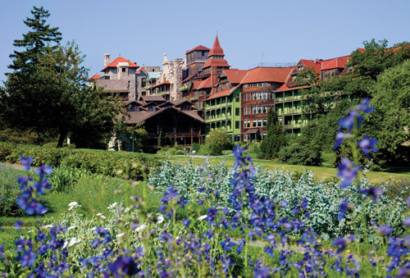](https://www.mohonk.com/)

[**Mohonk Mountain House**](https://www.mohonk.com/)

A 19th century Victorian castle spa resort surrounded by 40,000 acres of protected forest, hiking/biking trails and a lake for swimming, kayaking and ice skating.

[](http://www.saugertieslighthouse.com/)

[**Saugerties Lighthouse**](http://www.saugertieslighthouse.com/)

A restored lighthouse on the Hudson River offers panoramic views of the Hudson Valley and the Catskill Mountains.

[](http://www.olddutchchurch.org/)

[**Old Dutch Church**](http://www.olddutchchurch.org/)

A National Historic Landmark in Uptown Kingston surrounded by a Revolutionary War-era cemetery.

[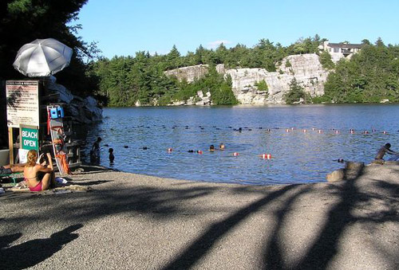](https://parks.ny.gov/parks/127/details.aspx)

[**Lake Minnewaska**](https://parks.ny.gov/parks/127/details.aspx)

A scenic one-mile long lake – and 33 miles of carriage roads and 50 miles of footpaths – in the Minnewaska State Park Preserve along the Shawangunk Ridge.

<http://ulstercountyny.gov/ulsterforbusiness/featured-properties>

**Featured Properties**

**From farmland to factory space, Ulster County offers hundreds of affordable options.**

Ulster County has millions of square feet of commercial and industrial space available immediately. With New York State and local incentives, businesses are taking advantage of government support and abundant, affordable real estate. Whether your business requires a small storefront or 18,000 square feet of light industrial space, the Ulster County Office of Economic Development can help you find what you need.

* + [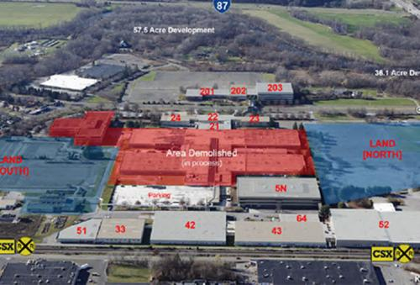](http://ulstercountyny.gov/ulsterforbusiness/properties/enterprise-corporate-park-tech-city)
* NEED A BETTER IMAGE FOR THIS SITE
* [**Enterprise Corporate Park / Tech City**](http://ulstercountyny.gov/ulsterforbusiness/properties/enterprise-corporate-park-tech-city) 101-899 Enterprise Drive, Kingston, N.Y. 12401  [**more >>**](http://ulstercountyny.gov/ulsterforbusiness/properties/enterprise-corporate-park-tech-city)
  + [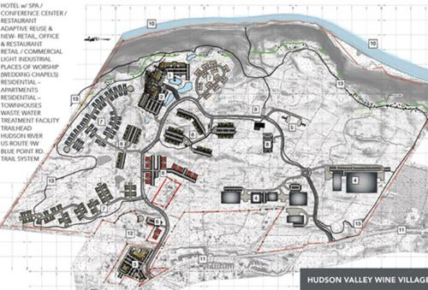](http://ulstercountyny.gov/ulsterforbusiness/properties/hudson-valley-wine-village)
* [**Hudson Valley Wine Village**](http://ulstercountyny.gov/ulsterforbusiness/properties/hudson-valley-wine-village) 191-200 Blue Point Road, Highland, N.Y, 12528  [**more >>**](http://ulstercountyny.gov/ulsterforbusiness/properties/hudson-valley-wine-village)
  + [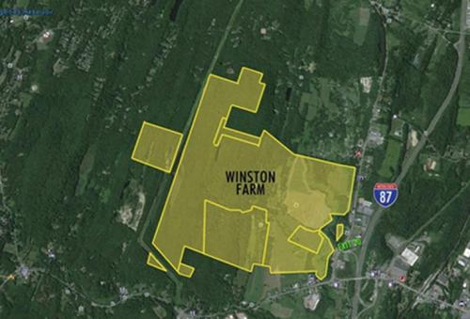](http://ulstercountyny.gov/ulsterforbusiness/properties/winston-farm)

[**Winston Farm**](http://ulstercountyny.gov/ulsterforbusiness/properties/winston-farm) 119 Augusta Savage Road, Saugerties, N.Y. 12477  [**more >>**](http://ulstercountyny.gov/ulsterforbusiness/properties/winston-farm)

<http://ulstercountyny.gov/ulsterforbusiness/properties/enterprise-corporate-park-tech-city>



[Enterprise Corporate Park / Tech City](http://ulstercountyny.gov/ulsterforbusiness/properties/enterprise-corporate-park-tech-city)

101-899 Enterprise Drive, Kingston, N.Y. 12401

<http://ulstercountyny.gov/ulsterforbusiness/properties/hudson-valley-wine-village>

**Size**

**Size**

156 acres as one parcel or subdivided

**Condition**

Existing building and shovel-ready sites

**Sale or Lease**

Lease/Sale

**Key Features**

Easy access to N.Y.S. Interstate 87 (Exit 19) in Kingston. The site has access to water/sewer, natural gas, phase 3 electricity, and broadband/dark fiber access; also CSX rail access and heliport.

**Possible Uses**

* Technology development, manufacturing, research & development facility, data center, media post-production, or indoor farming

[Hudson Valley Wine Village](http://ulstercountyny.gov/ulsterforbusiness/properties/hudson-valley-wine-village)

191-200 Blue Point Road, Highland, N.Y. 12528

**Size**

Pre-approvals for this 437-acre development site include:

* Light industrial - 450,000 SF
* Commercial and office - 155,000 SF
* Hotel & conference center
* Residential - 800 Units

**Condition**

Shovel-ready

**Sale or Lease**

Lease/Sale

**Key Features**

The site is located at the midpoint between New York and Albany and across the Hudson River from Poughkeepsie. It is a 90-minute drive to Manhattan, a 65-minute drive to Albany, a 50-minute drive to White Plains, and provides easy access to every major market in the Northeast.

**Possible Uses**

Commercial, light industry and hotel/conference center development

<http://ulstercountyny.gov/ulsterforbusiness/properties/winston-farm>

[Winston Farm](http://ulstercountyny.gov/ulsterforbusiness/properties/winston-farm)

119 Augusta Savage Road, Saugerties, NY 12477

**Size**

736 acres as one parcel or subdivided

**Condition**

Shovel-ready

**Sale or Lease**

Sale

**Key Features**

Easy access to N.Y.S. Interstate 87 (Exit 20) at the intersection of Route 32 in Saugerties. The site has access to water/sewer, natural gas, phase 3 electricity, and broadband.

**Possible Uses**

Technology development, manufacturing, research & development facility, eco-tourism or indoor farming

<http://ulstercountyny.gov/ulsterforbusiness/grants>

**Grant Opportunities**

**Let us help you find the right grant for your business or project.**

Ulster County’s businesses have access to a wide variety of public and private grant funding resources. The county maintains a current list of available opportunities on its website, and Ulster County Office of Economic Development assists businesses with completing grant applications. For more information, [visit the county’s grant page](http://ulstercountyny.gov/planning/grants-announcement-2017).

<http://ulstercountyny.gov/ulsterforbusiness/events>

**Upcoming Events**

**Featured events for current and prospective business owners.**

Ulster County hosts and features a variety of events to help businesses succeed. From grant writing workshops and meet-and-greets to food and craft beverage showcases and tours of new manufacturing facilities, Ulster County offers frequent opportunities to network and learn valuable skills.

Upcoming Events

DISREGARD TEXT FOR THE REMAINDER OF THIS SECTION, STILL A WORK IN PROGRESS. I see it changes in some automatic way…this was a cut and paste from earlier. Let’s discuss formatting changes for future.

Jun 21

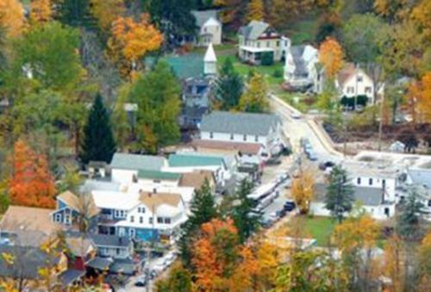

**Helping Communities by Helping Local Businesses (Shandaken|Hardenburgh|Denning Workshop)**

**Thu, Jun 21, 6:00 pm**

**Town Hall in Shandaken**

**7209 NY-28**

**Shandaken, NY**

County Executive Mike Hein and the Ulster County Office of Economic Development invite residents of the Shandaken area to learn more about the services we offer to support local businesses, nonprofits, and communities. Topics of discussion include:

* Funding assistance through grants and loans;
* Site assistance through site research and planning;
* Business counseling, training and networking; and
* Tax incentives, such as Payments-In-Lieu-Of-Taxes (PILOTs), tax credits, and tax abatements.

Come learn and discuss how county and local efforts to boost business can be an important part of helping our local economy grow and thrive!

This event is co-hosted by the Towns of Shandaken, Denning, and Hardenburgh; the Catskill Watershed Corporation and the Central Catskill Chamber of Commerce. The event is part of the Office of Economic Development's ongoing Community Economic Development initiative, which aims to engage with residents and business owners to help shape locally-driven economic development priorities. Future events are planned throughout 2018 at various locations across Ulster County. For more information, or for a list of other upcoming events organized by the Ulster County Office of Economic Development, visit [UlsterForBusiness.com](http://ulstercountyny.gov/ulsterforbusiness/UlsterForBusiness.com).

Jun 27

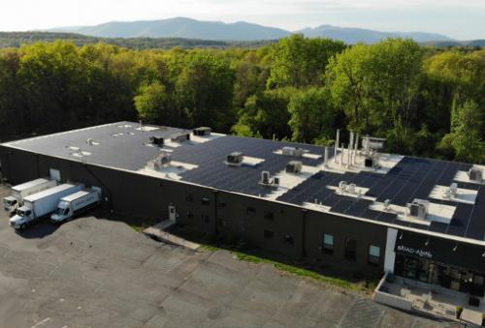

**Building Ulster County Together**

**Wed, Jun 27, 7:30 am**

**Best Western Plus Kingston**

**503 Washington Avenue**

**Kingston, NY**

Ulster County Executive Mike Hein, the Ulster County Climate Smart Committee, and the Ulster County Office of Economic Development invite you to attend the launch of the Green Business Challenge (GBC). The event will highlight local green business leaders such as Bread Alone and will take place at Best Western, 503 Washington Ave., Kingston. Breakfast will be served at 7:30 a.m., and presentations will begin at 8:00 a.m. Attendees will have a chance to speak with vendors, presenters and GBC Ambassadors.

Cost: $20 (includes breakfast)

The Ulster County Green Business Challenge is designed to encourage businesses, organizations and municipalities to reduce greenhouse gas emissions, mitigate climate change and reap considerable savings. This program also supports local green building contractors, renewable energy providers and other businesses that implement sustainability practices. Learn more about the Challenge at <http://ulstercountyny.gov/greenbusinesschallenge>.

Past Events

May 5



**Hudson Valley Film and Television Industry Mixer**

**Sat, May 5, 3:30 pm**

**Hudson River Maritime Museum**

**50 Rondout Landing**

**Kingston, NY**

Ulster County Executive Michael P. Hein is pleased to invite you to an industry mixer for Hudson Valley film and television professionals. The event includes a roundtable with producers, a panel discussion and a networking reception co-hosted by Stockade Works, the Producers Guild of America, the Hudson River Maritime Museum and the Ulster County Film Office.

Local film/TV professionals are encouraged to take advantage of this opportunity to collaborate and discuss ways to increase the number of film/TV productions made locally.

**WHAT:** Hudson Valley Film and Television Industry Mixer with Producers Roundtable and Panel Discussion

**WHEN:** Saturday, May 5th, 2018

**3:30 PM:** Producers Roundtable offering advice and conversation with industry veterans Alison Beckett (The Nutcracker & the Four Realms), Janet Grillo (Jack of All Hearts), Julie Goldman (Life, Animated) and William Horberg (The Talented Mr. Ripley); presented by the Producers Guild of America

**5:00 PM**: Panel Discussion on the film/TV industry in the Hudson Valley, featuring Meira Blaustein, Jonathan Burkhart, and Mary Stuart Masterson; moderated by Beth Davenport

Networking reception follows

**WHERE:** Hudson River Maritime Museum, 50 Rondout Landing, Kingston

[Reserve your free tickets online by clicking here](https://ucoed-filmtvmixer-2018.eventbrite.com/), and please encourage your friends and colleagues from the industry to participate.

**NOTE: Seating is limited for the Producers Roundtable, so register today.**

Light fare, beer and wine will be provided by our generous sponsors: Bread Alone, Keegan Ales, the Stone Pony, and Whitecliff Vineyard and Winery.

Apr 17



**Ulster County Craft Food and Beverage Industry Mixer**

**Tue, Apr 17, 5:30 pm**

**The Falcon**

**1348 US Route 9W**

**Marlboro, NY**

To help Ulster County's food and beverage manufacturers address the challenges of logistics and distribution, County Executive Mike Hein and the Office of Economic Development are excited to present Michael Rozyne, founder of the innovative local food distribution company Red Tomato, and Todd Erling, Executive Director of the Hudson Valley Agri-business Development Corporation.

Light appetizers will be served, with a cash bar and items from a limited dinner menu available for purchase.

Before and after the presentations we invite you to mix, mingle and network with other food and beverage leaders from throughout Ulster County and the region.

[Click here to RSVP.](https://ucoed-foodbev-2018.eventbrite.com/)

**Speaker Bios**

**Michael Rozyne** has been a marketer of family farm products for three decades. He worked on conventional and organic farms in Maine, and was Purchaser and Marketer for a regional food distributor in New England. He was cofounder of the fair trade coffee company, Equal Exchange. He started [Red Tomato](https://www.redtomato.org/), a decentralized food hub in the Northeast, in 1996 and now works as Red Tomato’s Evangelist focusing on the growers, new business development, and product development.

Following Michael's remarks, **Todd Erling**, Executive Director of[Hudson Valley Agribusiness Development Corporation](https://www.hvadc.org/) will unveil the results of a recent study on food and beverage processing in Ulster County. With HVADC’s Board of Directors, Todd has developed the first regional entity to focus on farms and local food business as economic development in the Hudson Valley. HVADC provides assistance to ag-related and ag-dependent businesses through contracts with seven counties throughout the Hudson Valley. Since 2007 HVADC has assisted projects in accessing over $30 million in funding.

Apr 10

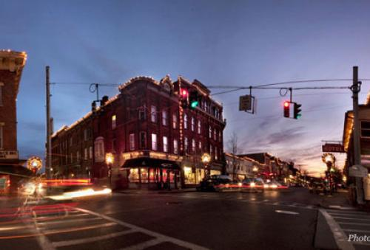

**Helping Saugerties by Helping Local Business**

**Tue, Apr 10, 6:00 pm**

**Saugerties Senior Center**

**207 Market St**

**Saugerties, NY**

County Executive Mike Hein and the Ulster County Office of Economic Development invite residents of the Saugerties area and local business owners to learn more about the services we offer to support local businesses, nonprofits and communities. Topics of discussion include:

* Funding assistance through grants and loans;
* Site assistance through site research and planning;
* Business counseling, training and networking; and
* Tax incentives, such as Payments-In-Lieu-Of-Taxes (PILOTs), tax credits, and tax abatements.

Come learn and discuss how county and local efforts to boost business can be an important part of helping our local economy grow and thrive!

This event is co-hosted by the Saugerties Chamber of Commerce  and the Town of Saugerties. The event is part of the Office of Economic Development's ongoing Community Economic Development initiative, which aims to engage with residents and business owners to help shape locally-driven economic development priorities. Future events are planned throughout 2018 at various locations across Ulster County. For more information, or for a list of other upcoming events organized by the Ulster County Office of Economic Development, visit [UlsterForBusiness.com](http://www.ulsterforbusiness.com/).

[Click here to RSVP.](https://ucoed-saugerties-2018.eventbrite.com/)

Apr 9

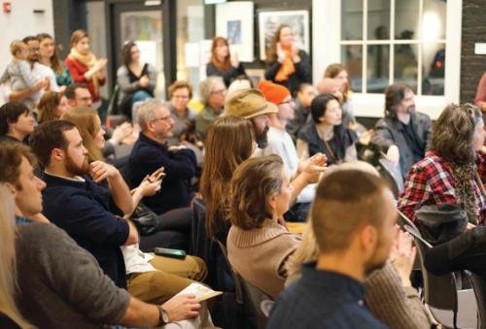

**Helping New Paltz by Helping Local Businesses**

**Mon, Apr 9, 6:00 pm**

**Hampton Inn by Hilton New Paltz**

**4 South Putt Corners Road**

**New Paltz, NY**

NOTE: This event was previously scheduled for March 7, but was rescheduled due to weather. The new date/time is Monday, April 9th from 6:00-8:00 PM. To ensure that we have your registration information, please RSVP below even if you had previously registered for the March 7th event. Thank you!

County Executive Mike Hein and the Ulster County Office of Economic Development invite residents of the New Paltz area and local business owners to learn more about the services we offer to support local businesses, nonprofits and communities. Topics of discussion include:

* Funding assistance through grants and loans;
* Site assistance through site research and planning;
* Business counseling, training and networking; and
* Tax incentives, such as Payments-In-Lieu-Of-Taxes (PILOTs), tax credits, and tax abatements.

Come learn and discuss how county and local efforts to boost business can be an important part of helping our local economy grow and thrive!

This event is co-hosted by the New Paltz Regional Chamber of Commerce  and the Town of Esopus. The event is part of the Office of Economic Development's ongoing Community Economic Development initiative, which aims to engage with residents and business owners to help shape locally-driven economic development priorities. Future events are planned throughout 2018 at various locations across Ulster County. For more information, or for a list of other upcoming events organized by the Ulster County Office of Economic Development, visit UlsterForBusiness.com.

[Click here to RSVP.](https://ucoed-newpaltz-2018-2.eventbrite.com/)

Apr 4

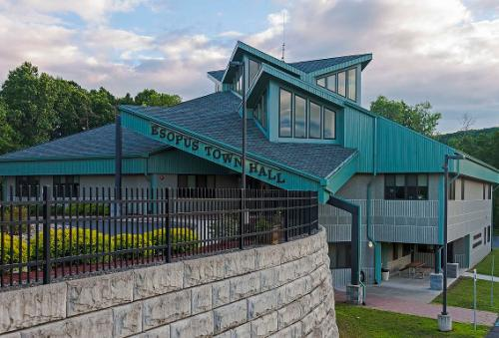

**RESCHEDULED: Helping Esopus by Helping Local Businesses**

**Wed, Apr 4, 5:30 pm**

**Esopus Town Hall**

**284 Broadway**

**Ulster Park, NY**

NOTE: This event was previously scheduled for March 21, but was rescheduled due to weather. The new date/time is Wednesday, April 4th from 5:30-7:30 PM. If you RSVPed for the original date, you do not need to re-register. If you have registered but do not plan to attend on the new date, please email [twei@co.ulster.ny.us](mailto:twei@co.ulster.ny.us) to notify us.

County Executive Mike Hein and the Ulster County Office of Economic Development invite residents of the Esopus area and local business owners to learn more about the services we offer to support local businesses, nonprofits and communities. Topics of discussion include:

* Funding assistance through grants and loans;
* Site assistance through site research and planning;
* Business counseling, training and networking; and
* Tax incentives, such as Payments-In-Lieu-Of-Taxes (PILOTs), tax credits, and tax abatements.

Come learn and discuss how county and local efforts to boost business can be an important part of helping our local economy grow and thrive!

This event is co-hosted by the Esopus Business Alliance and the Town of Esopus. The event is part of the Office of Economic Development's ongoing Community Economic Development initiative, which aims to engage with residents and business owners to help shape locally-driven economic development priorities. Future events are planned throughout 2018 at various locations across Ulster County. For more information, or for a list of other upcoming events organized by the Ulster County Office of Economic Development, visit UlsterForBusiness.com.

[Click here to RSVP.](https://ucoed-esopus-2018.eventbrite.com/)

Apr 2

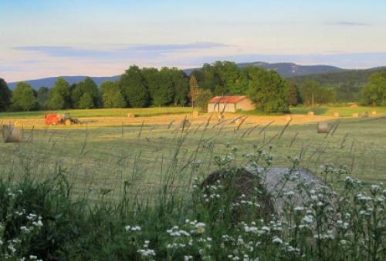

**Supporting Local Agribusiness**

**Mon, Apr 2, 6:00 pm**

**Town of Rochester Community Center**

**15 Tobacco Road**

**Accord, NY**

County Executive Mike Hein, the Ulster County Office of Economic Development and Town of Rochester Supervisor Mike Baden invite you to a presentation and discussion of local services available to support farms and food/beverage producers in the Town of Rochester.

**WHEN:**Monday, April 2nd from 6:00 – 7:30 PM.

**WHERE:** Town of Rochester Community Center, 15 Tobacco Road, Accord, NY 12404.

**WHO:** Farmers and growers, food processors/manufacturers, and beverage-makers, plus businesses that support local farms and food/beverage producers.

**WHAT:** An overview of services offered by Ulster County and the Town of Rochester, the Mid-Hudson Small Business Development Center, and Hudson Valley Agribusiness Development Center, with an opportunity to ask questions or connect with us for further discussion about your business’ needs.

This event is hosted by the Town of Rochester and the Ulster County Office of Economic Development. For more information about the UCOED, visit us online at <http://ulstercountyny.gov/economic-development>. Special thanks to the [Mid-Hudson Small Business Development Center](http://www.nyssbdc.org/centers/centers.aspx?centid=94) and the [Hudson Valley Agribusiness Development Center](https://www.hvadc.org/) for their participation.

[**Click here to RSVP.**](https://ucoed-rochester-2018.eventbrite.com/)

Mar 7



**Helping Communities by Helping Local Businesses (New Paltz Workshop)**

**Wed, Mar 7, 6:00 pm**

**Hampton Inn by Hilton New Paltz**

**4 South Putt Corners Road**

**New Paltz, NY**

UPDATE: As of 6pm on 3/6/2018 this event has been CANCELLED due to predictions of a winter storm in our area. The event will be rescheduled.

County Executive Mike Hein and the Ulster County Office of Economic Development invite residents of the New Paltz area to learn more about the services we offer to support local businesses, nonprofits and communities. Topics of discussion include Payments-In-Lieu-Of-Taxes (PILOTs), tax abatements, site assistance, grants, business counseling and more. Come learn and discuss how county and local efforts to boost business can be an important part of helping our local economy grow and thrive!

This event is co-hosted by the New Paltz Regional Chamber of Commerce and the Town and Village of New Paltz. The event is part of the Office of Economic Development's ongoing Community Economic Development initiative, which aims to engage with residents and business owners to help shape locally-driven economic development priorities. Future events are planned throughout 2018 at various locations across Ulster County. For more information, or for a list of other upcoming events organized by the Ulster County Office of Economic Development, visit UlsterForBusiness.com.

THIS EVENT HAS BEEN CANCELLED DUE TO WEATHER.

Nov 15

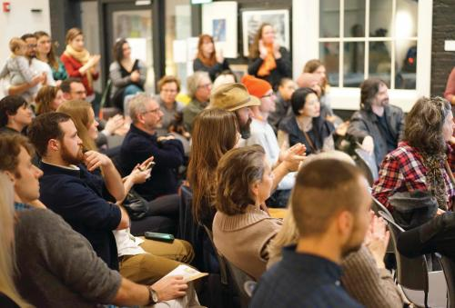

**How Ulster County Does Business Differently**

**Wed, Nov 15, 6:00 pm**

**Ulster County Legislative Chambers**

**244 Fair St**

**Kingston, NY**

What are we doing to support local businesses in Ulster County, you ask? To find out, join staff from the Ulster County Office of Economic Development and the City of Kingston for an overview of the services provided to businesses, nonprofits and communities. Topics of discussion include Payments-In-Lieu-Of-Taxes (PILOTs), sales and mortgage tax abatements, site assistance, grants, business counseling and more. Come learn how your government helps existing businesses in our area grow and thrive. With special thanks to KingstonCitizens.org.

To RSVP, [click here](https://www.eventbrite.com/e/economic-development-services-in-ulster-county-and-kingston-tickets-39527190892).

Nov 1

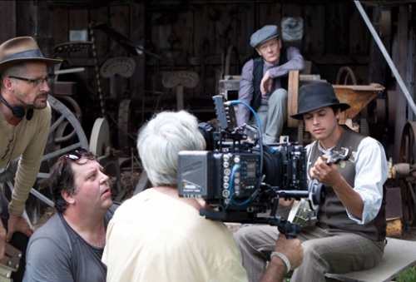

**Riding the Film Wave: How Your Business Can Benefit (11/1)**

**Wed, Nov 1, 6:00 pm**

**SUNY New Paltz, Lecture Center Room 1001**

**New Paltz, NY**

**Whether you've worked with film productions already, or are new to the game; whether you're an accountant, a medic, a caterer or a landscaper; whether you own a building you think is film-worthy or a home that you'd like to make available for film cast and crew - this event is for everyone!**

Have you noticed the film crews roaming throughout Ulster County this year? Thanks to the recent expansion of the NYS Film Tax Credit, which was spearheaded by Ulster County Executive Mike Hein, business is booming with more productions and spending in the first quarter of 2017 than in the entirety of 2016 and years prior.

But the million dollar question is "how does MY business get a piece of the pie?"

Ulster County Executive Mike Hein, the Ulster County Office of Economic Development and the Hudson Valley Film Commission are pleased to invite you to attend one of the two upcoming workshops on how you can do more business with the film industry. During the workshop, our team will answer questions such as:

* What kind of vendors does the film industry need?
* How do I get my business onto production vendor lists?
* What else can I do to put my business in front of the decision-makers in the film industry?

**NOTE: This event will be held twice, at different locations and times. Both events will cover the same material, so we encourage you to pick the date/place that is most convenient for you.**

[**Click here to RSVP for the 10/24 workshop in Saugerties**](https://2017filmbusinesses1.eventbrite.com/)

[**Click here to RSVP for the 11/1 workshop in New Paltz**](https://2017filmbusinesses2.eventbrite.com/)

Oct 24



**Riding the Film Wave: How Your Business Can Benefit (10/24)**

**Tue, Oct 24, 4:00 pm**

**The Stone Pony Delicatessen and Pizzeria**

**963 Kings Highway**

**Saugerties, NY**

**Whether you've worked with film productions already, or are new to the game; whether you're an accountant, a medic, a caterer or a landscaper; whether you own a building you think is film-worthy or a home that you'd like to make available for film cast and crew - this event is for everyone!**

Have you noticed the film crews roaming throughout Ulster County this year? Thanks to the recent expansion of the NYS Film Tax Credit, which was spearheaded by Ulster County Executive Mike Hein, business is booming with more productions and spending in the first quarter of 2017 than in the entirety of 2016 and years prior.

But the million dollar question is "how does MY business get a piece of the pie?"

Ulster County Executive Mike Hein, the Ulster County Office of Economic Development and the Hudson Valley Film Commission are pleased to invite you to attend one of the two upcoming workshops on how you can do more business with the film industry. During the workshop, our team will answer questions such as:

* What kind of vendors does the film industry need?
* How do I get my business onto production vendor lists?
* What else can I do to put my business in front of the decision-makers in the film industry?

**NOTE: This event will be held twice, at different locations and times. Both events will cover the same material, so we encourage you to pick the date/place that is most convenient for you.**

[**http://ulstercountyny.gov/ulsterforbusiness/why-ulster**](http://ulstercountyny.gov/ulsterforbusiness/why-ulster)

**LIVING HERE** – This page •should• be a landing page for the entire section on Living Here, yet content only features Why Ulster. Can you create a new URL for it with the following content (and keep the URL for Why Ulster)?

NEW CONTENT PENDING

<http://ulstercountyny.gov/ulsterforbusiness/why-ulster>

**Why Ulster County?**

**We have world-class scenery, outstanding recreation and a vibrant focus on the arts, culture and history.**

Situated between the iconic Hudson River and the beautiful Catskill Mountains, Ulster County has beautiful scenery and world-class outdoor recreation. Residents enjoy easy access to the outdoors, close proximity to New York City, and a creative culture steeped in history and the arts.

Besides being a great place to live, Ulster County is also a great place to establish or grow your business. With close proximity to New York City, and easy access to the New York State Thruway and major air-and-rail transportation hubs, Ulster County’s businesses are connected to some of the largest markets in the world. Inexpensive real estate and a lower cost of living give Ulster County’s businesses a competitive advantage, helping them thrive. Whether you’re running a small mom-and-pop operation or serving Fortune 500 clients around the world, Ulster County is the perfect place for your business.

[Visit Ulster County Tourism](http://www.ulstercountyalive.com/) for more information about the area’s many attractions.



**35 mountain peaks**

Reaching elevations of more than 3,500 feet.



**350 miles of hiking trails**

Mountain treks, casual woodland walks and urban greenways.



**world-class**

Rock climbing and mountain biking—plus a growing network of rail trails which will connect to the statewide Empire State Trail.



**12 golf courses**

including the award-winning Mohonk Golf Course and several public courses.



**90 min. from NYC**

With direct buses, nearby Amtrak and MetroNorth train services, and easy access to major airports and the N.Y.S. Thruway, getting here couldn’t be easier.



**$215,000**

Median sale price of homes in 2017. Compared to $616,250 in Westchester County or $500,000 in Nassau. ([click here for source](https://www.tax.ny.gov/research/property/assess/sales/resmedian.htm))

<http://ulstercountyny.gov/ulsterforbusiness/cities>

**Cities and Towns**

**Ulster County’s cities and towns are vibrant and filled with history, culture and attractions.**

The Hudson River Communities

**Saugerties, Kingston, Marlboro, Lloyd, Highland, Esopus, Hurley, Ulster**

The Hudson River, one of the world’s most iconic waterways, creates Ulster County’s eastern border. Since Henry Hudson’s first exploration in 1609, the Hudson River has been a locus of American innovation: It played a pivotal role in the early colonies’ fight for independence, fueled the nation’s westward expansion and gave birth to both the Hudson River School of American art and, thanks to the efforts of such luminaries as Pete Seeger and Robert Kennedy Jr., the modern environmental movement. Today, Ulster County’s riverside communities are revitalized as more and more people join them. Kingston, the historic heart of Ulster County, is brimming with creative energy. It is home to artists and entrepreneurs, and is quickly becoming a hub for the Hudson Valley’s tech industry. Saugerties is an old mill town with beautiful industrial architecture and a vibrant, eclectic arts scene. Farther south, the Town of Lloyd in Highland is the entry point for many coming to Ulster County from the east. Sitting at one end of the Walkway Over the Hudson, it attracts millions of visitors every year. Marlboro is a charming small town surrounded by verdant, rolling hills, acres of farmland and orchards, and several exceptional wineries. The Town of Ulster is known as the “Business Hub” of the county, though it’s also characterized by several quiet hamlets and residential neighborhoods. To the south and west, respectively, of Kingston, the Towns of Esopus and Hurley offer outdoor recreation, historic attractions and a number of picturesque neighborhoods, hamlets and villages within their borders.

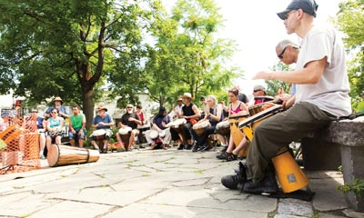

The Catskills

**Woodstock, Phoenicia, Shandaken, Denning, Hardenburgh, Olive**

Ulster County’s towering Catskill Mountains offer breathtaking scenery and incredible views. Small, charming towns like Phoenicia and Shandaken—and the lightly populated westernmost communities of Denning and Hardenburgh—are popular for four-season outdoor recreation, with easy access to some of the best hiking, skiing, mountain biking, fishing and kayaking in the Northeast. The demand for pure, clean drinking water for New York City inhabitants changed the course of history for the Town of Olive: The Ashokan Reservoir now divides the sprawling town into hamlets that border the shoreline of the massive handmade dam and its forever wild Catskill forest lands. At the foot of the Catskill Mountains lies Woodstock, world-famous for nurturing the creative spirit of American icons like Bob Dylan. Today, Woodstock remains a cultural hub for artists and musicians. It hosts the Woodstock Film Festival, a yearly celebration of independent film frequented by A-list actors and film industry veterans in a casual, down-to-earth atmosphere, and Woodstock Bookfest, an annual gathering of aspiring writers, book lovers, publishers, agents and award-winning authors.



The Rondout and Wallkill Valleys

**Ellenville, Kerhonkson, Accord, High Falls, Stone Ridge, Marbletown, Plattekill, Rochester, Wawarsing**

The beautiful Rondout Creek and Wallkill River valleys cut a corridor from the Hudson River to Ulster County’s southwestern borders. Charming, historic towns like Stone Ridge, High Falls and Accord punctuate acres of rolling farmland. The Village of Ellenville is primed to become one of the region’s economic drivers due to the Ellenville Million, a funding initiative from the County Executive’s office. This infusion of funding is helping to jumpstart local development and investment, and includes funding for businesses looking to expand or relocate to the area. Real estate is already very affordable and, with the added incentives, there’s never been a better time to invest in Ellenville’s future.

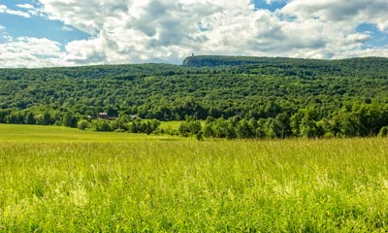

The Shawangunks

**New Paltz, Gardiner, Rosendale**

The breathtaking Shawangunk Ridge has given inspiration to the area’s residents for centuries. New Paltz, a colorful college town with some of the region’s best restaurants, sits at the base of the ridge. S.U.N.Y. New Paltz is an economic driver for the region, and has received national attention for the quality, breadth and affordability of its academic programs—not to mention its innovative [3-D Printing Center](https://www.newpaltz.edu/3d/). Rosendale is a quaint and charming small town with an active community. Further south, Gardiner has become a hub for craft beverages, with several wineries and Tuthilltown Distillery, the first new whiskey maker to open in New York State since Prohibition.

<http://ulstercountyny.gov/ulsterforbusiness/video>

**VIDEOS**

Subscribe to the Ulster for Business YouTube Channel [here](https://www.youtube.com/channel/UCX_vXOjrhXky-9tTb6wG2Rg).

Is this the correct link – on ‘here’ above - for the Ulster for Business YouTube channel – or is it coded as my channel?

https://www.youtube.com/channel/UCX_vXOjrhXky-9tTb6wG2Rg

**Ulster County Welcomes Niche Manufacturers!** Small manufacturing is thriving here in Ulster County, thanks to the support and resources offered by the Ulster County Office of Economic Development. Four diverse niche manufacturers talk about why Ulster County is the best place for their businesses to gain strength, expand and succeed.

**Do Business Differently in Ulster County** Less than 100 miles from midtown Manhattan, in Ulster County, New York, tech industry leaders are discovering new ways to successfully manage their businesses, raise their families and enjoy a better quality of life—all at a lower cost of living.

**Ulster is Camera Ready - The Film Industry in Ulster County** More and more film and television productions are choosing Ulster County, N.Y. for its diverse shooting locations, its proximity to N.Y.C. and its experienced and professional local talent pool. Tax credits of up to 45% provide added incentives. Find out about how you can shoot your next film here!

**Living In Ulster County - The Tech Community** Ulster County is a vibrant tech center just 100 miles north of New York City. A robust community of interactive professionals meets regularly in the beautiful and historic Stockade District of Kingston, N.Y.

**Living in Ulster County - Dennis Crowley Testimonial** Dennis Crowley of Foursquare talks about how Ulster County and New York City are connected via just a quick ride on the N.Y.S. Thruway. After a brief period of settling in and establishing himself, he now enjoys easy connectivity with other entrepreneurs in the tech industry in the same vicinity.

**Living in Ulster County: Garnet Heraman & Karina Cousineau Testimonial** Garnet Heraman & Karina Cousineau talk about how Ulster County is a great place to live and launch a fashion-related manufacturing business in Phoenicia, N.Y., with a retail storefront in Uptown Kingston.

**Living in Ulster County: Norm Magnusson Testimonial** Norm Magnusson, a freelance creative director, talks about how Ulster County offers the best of both worlds: 'wilderness' within easy reach and quick accessibility to N.Y.C. He enjoys abundant opportunities to network with creatives and technologists right here in Ulster County.

<http://ulstercountyny.gov/ulsterforbusiness/blog>

**BLOG**

**TEXT FOR THIS “BLOG” SECTION IS STILL A WORK IN PROGRESS – NO NEED TO CHANGE TODAY—WILL SEND UPDATED CONTENT LATER.**

**Business Blog**

**News and resources for current and prospective Ulster County businesses.**

Recent Posts

[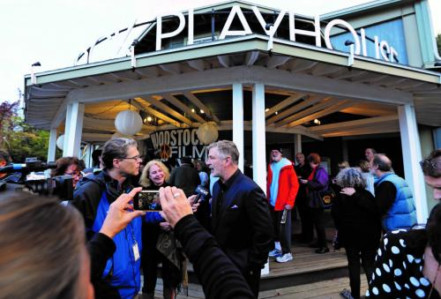](http://ulstercountyny.gov/ulsterforbusiness/blog/love-film-woodstock-film-festival)

[**For the Love of Film: The Woodstock Film Festival**](http://ulstercountyny.gov/ulsterforbusiness/blog/love-film-woodstock-film-festival)

From its humble origins, the Woodstock Film Festival has grown into a cultural tour de force, attracting big names from across the world. And once they experience Ulster County, many of them come back.

[**more >>**](http://ulstercountyny.gov/ulsterforbusiness/blog/love-film-woodstock-film-festival)

[](http://ulstercountyny.gov/ulsterforbusiness/blog/going-green)

[**Going Green: Ulster Is the Most Environmentally Friendly County in New York State**](http://ulstercountyny.gov/ulsterforbusiness/blog/going-green)

Fiscal responsibility and environmental sustainability are not mutually exclusive concepts to Ulster County Executive Mike Hein.

[**more >>**](http://ulstercountyny.gov/ulsterforbusiness/blog/going-green)

[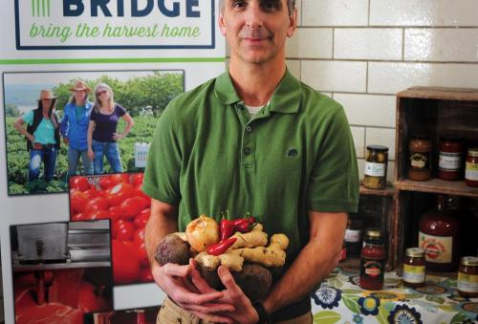](http://ulstercountyny.gov/ulsterforbusiness/blog/farm-to-fabulous)

[**Farm to Fabulous: Putting the Value in Value-Added**](http://ulstercountyny.gov/ulsterforbusiness/blog/farm-to-fabulous)

With vast and fertile farmland, knowledgeable local farmers, a welcoming community, and local

[**more >>**](http://ulstercountyny.gov/ulsterforbusiness/blog/farm-to-fabulous)

[](http://ulstercountyny.gov/ulsterforbusiness/blog/charles-ferri)

[**Star-struck: Charles Ferri’s New Destination Distillery in Esopus**](http://ulstercountyny.gov/ulsterforbusiness/blog/charles-ferri)

“I’m going to make the smoothest, most refined vodka in the marketplace,” says Charles Ferri,

[**more >>**](http://ulstercountyny.gov/ulsterforbusiness/blog/charles-ferri)

[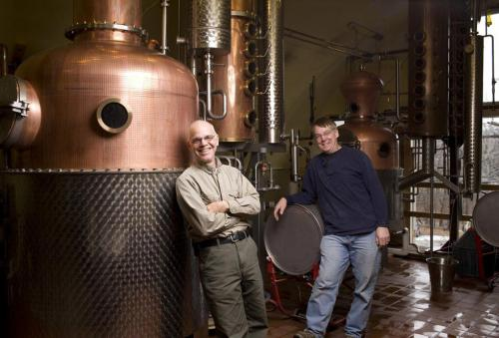](http://ulstercountyny.gov/ulsterforbusiness/blog/tuthilltown)

[**Tuthilltown: The Birthplace of Craft Distilling in New York State**](http://ulstercountyny.gov/ulsterforbusiness/blog/tuthilltown)

New York State’s craft beverage industry is booming. Locally distilled spirits contribute more than $27

[**more >>**](http://ulstercountyny.gov/ulsterforbusiness/blog/tuthilltown)

[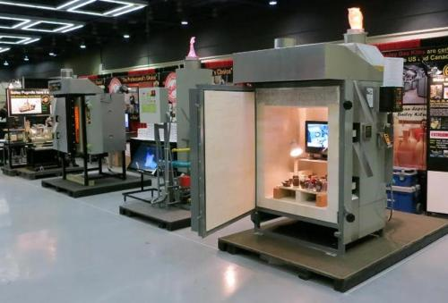](http://ulstercountyny.gov/ulsterforbusiness/blog/bailey-ceramic)

[**It Takes an Artist to Know an Artist: Bailey Ceramic Supplies**](http://ulstercountyny.gov/ulsterforbusiness/blog/bailey-ceramic)

For more than 42 years, Anne Shattuck Bailey and Jim Bailey have been revolutionizing the professional

[**more >>**](http://ulstercountyny.gov/ulsterforbusiness/blog/bailey-ceramic)

[**http://ulstercountyny.gov/ulsterforbusiness/blog/love-film-woodstock-film-festival**](http://ulstercountyny.gov/ulsterforbusiness/blog/love-film-woodstock-film-festival)

For the Love of Film: The Woodstock Film Festival

From its humble origins, the [Woodstock Film Festival](http://woodstockfilmfestival.org/) has grown into a cultural tour de force, attracting big names from across the world. Each year, actors like Alec Baldwin, Paul Rudd, Parker Posey, and Steve Buscemi gather with other famous directors and producers for a celebration of independent film. Woodstock Film Festival’s founders, Meira Blaustein and Laurent Rejto, launched the festival 18 years ago. “It’s not a red-carpet, stretch-limousine kind of thing,” says Blaustein. “People come here for the love of film and the love of filmmaking.”

And many end up staying. Dozens of visitors buy homes, or come back for their next production. “People fall in love with the area,” she says. “They come for the festival and then come back to make films.” The result is steady growth in the local film industry, year over year—and with a new tax credit of up to 45%, more filmmakers are attracted to Ulster County than ever.

In the past nine years, filmmakers have spent more than $70 million on productions in the region, including more than $8 million in 2016 alone. However, those numbers only account for direct spending; coupled with indirect spending at local hotels, restaurants, and shops the industry’s local impact adds up to nearly $15 million. The film industry also benefits a variety of local tradespeople, including sound engineers, camera operators, carpenters, electricians, and musicians. Currently, filmmakers hire 15 percent to 20 percent of their crews locally, but this number is projected to grow as the film industry in Ulster County continues to expand.

Ulster County has come a long way since the Woodstock Film Festival began in 2000. “It was arid ground in terms of film production,” says Blaustein. “It’s a very vibrant place now.” And as more and more visitors from the film industry fall in love with Ulster County, making films is becoming even easier. “Now there is a lot of infrastructure to support film production,” Blaustein says. “And it’s growing.” More recently, County Executive Mike Hein was instrumental in extending a massive tax cut to filmmakers, making Ulster County one of the most inexpensive places to film in New York State. Production has already seen a huge boost in 2017, bringing investment into local communities. If you’re a filmmaker looking for an amazing place for your next project, call the Ulster County Office of Economic Development at 845-340-3556 to see how we can help.

The 2017 Woodstock Film Festival will take place on October 11-15, 2017. For tickets and more information go to [www.woodstockfilmfestival.org](http://www.woodstockfilmfestival.org/).

[**http://ulstercountyny.gov/ulsterforbusiness/blog/going-green**](http://ulstercountyny.gov/ulsterforbusiness/blog/going-green)

Going Green: Ulster Is the Most Environmentally Friendly County in New York State

Ulster County Executive Mike Hein does not believe that fiscal responsibility and environmental sustainability are mutually-exclusive concepts. Instead, under his guidance, the  County is leading the way as the most environmentally-friendly county in New York State, and its commitment to clean energy has garnered national attention. In 2009, Ulster partnered with the nonprofit Green Infrastructure Center to develop comprehensive habitat mapping in order to preserve natural habitat while facilitating ecotourism. In 2015, Ulster earned a spot on the EPA’s list of top 30 local governments for green energy. And last December, the county was featured in National Geographic for its ongoing efforts in renewable energy, energy efficiency, and nature conservation. The article highlights successes like the John Burroughs Black Creek Corridor, which filled a gap in the wildlife pathway for Blueback herring and provided hundreds of acres of new trails for hikers.

Ulster County officials recognize the benefits of environmental preservation, not only to the ecosystem but to the local economy; in 2015, tourism revenues in the county reached their highest levels on record. Ulster’s attractions generated more than $530 million in tourism spending from visitors across the globe.

From border to border, the County converted its bus fleet to biodiesel, switched to LED street lighting, and is installing solar arrays to become even more efficient. Ulster purchases 100% of its electricity from renewable resources, making it the first and only net-carbon-neutral county so far in New York State. Ulster also boasts more than a dozen electric car-charging stations, the most municipal-sponsored locations in the State. It is also steadily converting its official vehicle fleet to fuel efficient and electric cars to cut carbon emissions.

SUNY Ulster’s Kingston Center was renovated from a former elementary school to Leadership in Energy and Environmental Design (LEED) standards, and boasts energy-efficient heating and cooling, LED lighting, car-charging stations, and permeable pavement and bioretention ponds that reduce stormwater runoff. County Executive Mike Hein envisioned and oversaw the project. “Ulster County is leading the way as the most environmentally friendly county in New York State,” he says. “I firmly believe that government must lead by example.”

Ulster County is doing business differently. If you think that what’s good for the environment can also be good for the bottom line, we want to help your business grow in Ulster County. Call us to see how we can help.

[**http://ulstercountyny.gov/ulsterforbusiness/blog/farm-to-fabulous**](http://ulstercountyny.gov/ulsterforbusiness/blog/farm-to-fabulous)

Farm to Fabulous: Putting the Value in Value-Added

With vast and fertile farmland, knowledgeable local farmers, a welcoming community, and local government willing to go to bat for businesses, Ulster County has earned its reputation as the epicenter of the farm-to-table movement. Farm Bridge’s Jim Hyland has never looked back since starting his business in Ulster County 10 years ago. “I’ve been really happy since we’ve been here. It’s been the best move I’ve ever made, for my business and for my family,” he says. “Ulster is just an ideal spot. We’re close to the city, Albany, and Boston. People can get to us very easily.”

Farm Bridge partners with local farmers to create value-added, shelf-stable products, and helps them sell what they grow without it spoiling. “We’re a bridge between farmers and the people who want their products,” says Hyland. They offer food production facilities, assistance with food regulations and co-packing and private labeling services for farmers and other food manufacturers. Farm Bridge also buys local produce like surplus tomatoes for salsa, basil-tomato sauce, or tomato juice, which it sells through wholesalers and area CSAs, such as Field Goods.

Over the past decade, Hyland has had a front row seat to the region’s changing food economy, and Farm Bridge’s output expanded by 55% between 2012 and 2015. “People are much more interested in where their food comes from,” he explains. Today, Ulster County is “a destination for people who care about their food.”

Ulster County actively supports its growing food and beverage market, notes Hyland. “They’ve been supportive since the very beginning,” he says. “They’re there for you if you have an issue.” Business owners have access to a variety of financial assistance, including tax abatements and grants, and recently Ulster County targeted a low-interest loan program toward the food and beverage industry, and simplified the application process.

Farmers and food producers are already feeling the impact, including Hyland, who says he recently received a loan through the county and is taking advantage of the opportunity to help grow Farm Bridge.

There are countless stories of Ulster County officials supporting businesses in other ways as well. Frequently, officials offer assistance in identifying and applying for grants, including the State’s highly competitive Consolidated Funding Application grants. One such recipient was Charles Ferri, who is preparing to open the Star Distillery and Estate in Esopus. The County Executive and Ulster County’s Office of Economic Development helped Ferri secure over $750,000 through State funding. “Without all of them working together, we might not be where we are now,” Ferri says.

To learn how we can help your business, contact us today.

[**http://ulstercountyny.gov/ulsterforbusiness/blog/charles-ferri**](http://ulstercountyny.gov/ulsterforbusiness/blog/charles-ferri)

Star-struck: Charles Ferri’s New Destination Distillery in Esopus

“I’m going to make the smoothest, most refined vodka in the marketplace,” says Charles Ferri, leaning forward on an antique couch in the back room of his wife’s real estate office. Ferri plans to open Star Distillery at the site of a former monastery on the Hudson River in Esopus, distilling ultra-premium vodka, gin, and whiskey.  A hotel and wedding venue are also planned for the site.

Ferri created the Star Vodka concept five years ago as a gift he could leave with VIPs at the Star Room, his Hamptons’ nightclub. The project took him to Moscow so he could see firsthand how some of the world’s most renowned brands make vodka. Ferri was unimpressed. “They were creating something as inexpensively as possible and telling people to mix it,” Ferri explains. He wanted a vodka so smooth it could be drunk on the rocks, and he realized he’d have to make it himself.

Opening a destination distillery in New York State was part of the plan all along, but Ferri was delighted that the stars aligned to bring him to the Hudson Valley, about 40 minutes’ drive from his childhood home in East Fishkill. “We’re right on the Hudson River, the most iconic river in the country,” he says. Plus, the area’s natural resources made it a perfect fit. “It’s about the water—the Northeast has some of the best water in the country,” he says. And the Hudson Valley is resistant to drought or water shortages that plague other areas.

Star Distillery’s location couldn’t be more advantageous. “The great thing about the Hudson Valley is, you’re right between Albany, Saratoga, and New York City,” Ferri explains. Because of interstates and several regional airports, sellers’ markets in Boston, Philadelphia, and Canada are easy to access. Another unexpected bonus is the outpouring of support from local governmental officials from across the Hudson Valley, especially Ulster County.

Ulster County Executive Mike Hein and Suzanne Holt, director of the Office of Economic Development, have done everything in their power to make the process of opening Star Distillery as painless as possible, Ferri says. “When you’re coming to a new region as a business owner it's so important to be welcomed, and they have really made this a nice and pleasant experience,” Ferri says. But Ulster County officials gave Ferri more than just a welcome. They also offered financial incentives, and even helped Ferri secure $750,000 in highly competitive state funding. “Without all of them working together, we might not be where we are now,” Ferri says.

As plans come together for the distillery, Ferri anticipates having the first batch of Hudson-Valley-made vodka and gin within 18 months. Almost immediately, he says, they’ll also begin producing and barreling whiskey in the hopes of launching a new line as soon possible. Ulster County helps new businesses like Ferri’s every day. Whatever it is your business needs, officials at Ulster County are here to help. Give us a call today to see the difference we can make.

<http://ulstercountyny.gov/ulsterforbusiness/blog/tuthilltown>

Tuthilltown: The Birthplace of Craft Distilling in New York State

New York State’s craft beverage industry is booming. Locally distilled spirits contribute over $27 billion to the State’s economy, and in the past five years alone, the number of distillers has grown by 500 percent. Governor Cuomo and State lawmakers have recognized the industry’s contributions by enacting legislation to make it easier to break into the business, and from Montauk to Fredonia, new breweries, distilleries, cideries and wineries are opening up at a blistering pace. But few people know that the boom began at a small craft distillery in the Ulster County town of Gardiner.

Founded in 2003, Tuthilltown Spirits Distillery was the first legal whiskey producer in New York State since Prohibition. For decades, legislation had made it extremely difficult for new distilleries to open, with licensing fees alone near $60,000. Everything changed, however, when Tuthilltown founders Ralph Erenzo and Brian Lee happened upon an obscure law allowing distilleries to get a license for only $1,450. Their discovery sparked a revolution, with dozens of distillers following their lead almost overnight. Erenzo and Lee lobbied legislators and convinced them of the benefits that distilling could bring to local economies—and New York State’s craft beverage renaissance began with the full support of leaders in government.

Today, Tuthilltown distributes throughout the tri-state area, and bars as far away as San Francisco carry its products. In April, Tuthilltown was acquired by independent family-owned Scottish distiller William Grant & Sons, with plans to expand production and distribution even further. The distillery has won numerous accolades, including Distillery of the Year from Whiskey Magazine and American Distillery of the Year from the American Distilling Institute. Tuthilltown has expanded into a variety of other spirits, including gin, vodka, and cordials made from local ingredients. But perhaps its biggest contribution has been putting the Hudson Valley on the map as a craft beverage leader.

Thanks in large part to Tuthilltown, Ulster County sits at the epicenter of New York’s burgeoning craft beverage movement, home to dozens of mouth-watering options for imbibers. Keegan Ales in Kingston got its start around the same time as Tuthilltown, and has enjoyed increasing popularity year after year. New to the scene, Arrowood Farms in Accord is at the vanguard of the farm-to-beer movement, growing hops and rye on site. Coppersea Distillery in New Paltz is handcrafting spirits the old-fashioned way, offering some incredible raw whiskies that cannot be found anywhere else. And as one of the nation’s largest apple-producing regions, it’s no surprise that new cideries are springing up across the county, too.

Ulster County officials have long supported new breweries, distilleries, cideries and wineries, recognizing the benefit to the local economy in sales, tourism, and sustainable jobs. Their support has allowed the craft beverage industry to thrive and has helped make Ulster County a destination for beverage enthusiasts. “Ulster County has a wonderful collection of breweries, wineries, cideries, and distilleries,” says County Executive Mike Hein. “Besides producing some of the best beer, wine, cider and spirits, they also contribute to our vibrant tourism industry, combining food offerings with tastings and tours, and providing beautiful outdoor spaces while visitors enjoy time spent with friends and family. Ulster County is quickly becoming the premier craft beverage destination for tourists in the Northeast.”

Even as the county’s craft beverage movement matures, there’s still millions of dollars of unmet demand both locally and in easily accessible metropolitan markets. Interested in learning more about how you can start, grow or relocate your business to Ulster County? If so, let our dedicated economic development team help you succeed. Reach out today to see how we can help!

<http://ulstercountyny.gov/ulsterforbusiness/blog/bailey-ceramic>

It Takes an Artist to Know an Artist: Bailey Ceramic Supplies

For over 42 years, Anne Shattuck Bailey and Jim Bailey have been revolutionizing the professional pottery world from a quiet side street in Midtown Kingston. In 1975, Jim released the 30-inch Bailey Slab Roller, unrivaled at the time for its ease-of-use and uniformity, even with dense clay. After an enthusiastic reception, business has been booming at the Bailey Ceramic Supplies & Bailey Pottery Equipment Corporation.

As professional potters, the Baileys have made an impact simply by making equipment they’d use themselves. As well as being a renowned potter, Jim has been designing custom tools since 1974; Anne’s work has been featured in books, museums, and even the White House. Today, the Baileys have more lines of pottery equipment and ceramics supplies than any other manufacturer in the industry.  The company’s central location in Kingston has contributed to the Baileys’ success.

Housed on Ten Broeck Avenue in midtown Kingston in a 100-year-old brick factory, Bailey’s Pottery is in good company among neighborhood artists’ studios and arts organizations; world-class art supply outfit R&F Handmade Paints is headquartered down the street. “Collaboration is an important part of the arts culture in Kingston,” Anne says.

Like many local creative arts organizations, Bailey’s finds the natural beauty of Ulster County to be a source of constant inspiration. “The city’s environment and quality of life are important to the company and its employees,” says Anne. The company also benefits from a pipeline of qualified workers graduating from SUNY New Paltz’s nationally recognized arts programs. Having employees who are all working artists themselves is important, notes Anne, because that helps them anticipate the needs of their customers.

Midtown Kingston is fast becoming a destination for the arts. There’s the recently created Midtown Arts District, which promotes the area as an artist-friendly place to live and work. Nonprofit development organization RUPCO rehabbed an abandoned factory and created the Lace Mill artists community, which offers subsidized housing for artists and frequently hosts gallery openings and tours. Along with other longstanding creative arts businesses like R&F Paints, Bailey’s has served as a catalyst for the neighborhood’s burgeoning arts scene, hosting pop-up shows and workshops to engage the community, donating equipment and time to local schools and causes, and working with both city and county government to promote the Midtown Arts District. In the past several years, they’ve been joined by other entrepreneurs in the arts, including Art Workshop Fabricators, Lite Brite Neon, and Black Creek Mercantile Trading Co.

“County and local leaders could not have been more supportive,” Anne says. Ulster County worked with other local business owners like developer Mike Piazza and architect Scott Dutton to help them find the perfect location at an affordable price. Today, County officials continue to aid other businesses in taking advantage of the area’s reasonable real estate. The Baileys continue to work with Kingston and Ulster County to support local artists, helping to make the region an even more attractive place to live.

Through partnerships with local businesses like Bailey’s, County support is giving rise to a thriving creative community in Kingston. Whether you’re a business owner, an artist, or both, Ulster County’s here to help. Call us today to see how we can make a difference.